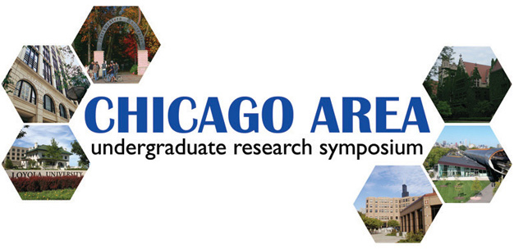
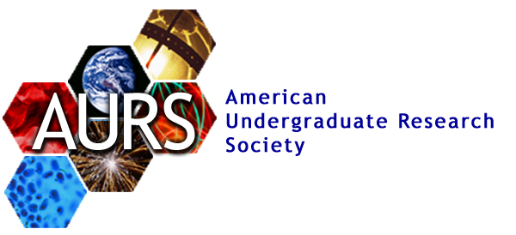

You are cordially invited to the

2007 Chicago Area Undergraduate Research Symposium

Loyola University Chicago Law Center
25 E. Pearson Street, Chicago
April 14, 2007, 10:00 am – 6:00 pm

The American Undergraduate Research Society (AURS) is proud to present the Chicago Area Undergraduate Research Symposium, an annual event held each spring that allows hundreds of undergraduates from six outstanding Chicago area universities the opportunity to present their research results in a professional setting. This event provides an excellent opportunity for students to learn about the research of their peers, speak to the attending university faculty, interact with industry representatives, and receive both wisdom and inspiration from the invited speakers. Members of the larger Chicago and Midwest scientific research community are invited to attend.

Sponsored by the University of Chicago, Loyola University, Northwestern University, DePaul University, Illinois Institute of Technology, and the University of Illinois at Chicago

RSVP to info@caurs.com
Please visit our website at www.caurs.com for full schedule and details.

